Client’s Meeting

Product

Birthday

Email

Phone

Meeting Date

Meeting Time

Client Name

Client’s Information

Meeting List

Meeting Information

Command Output Box

Command Input Box

Client Information

Number of Records

Client List

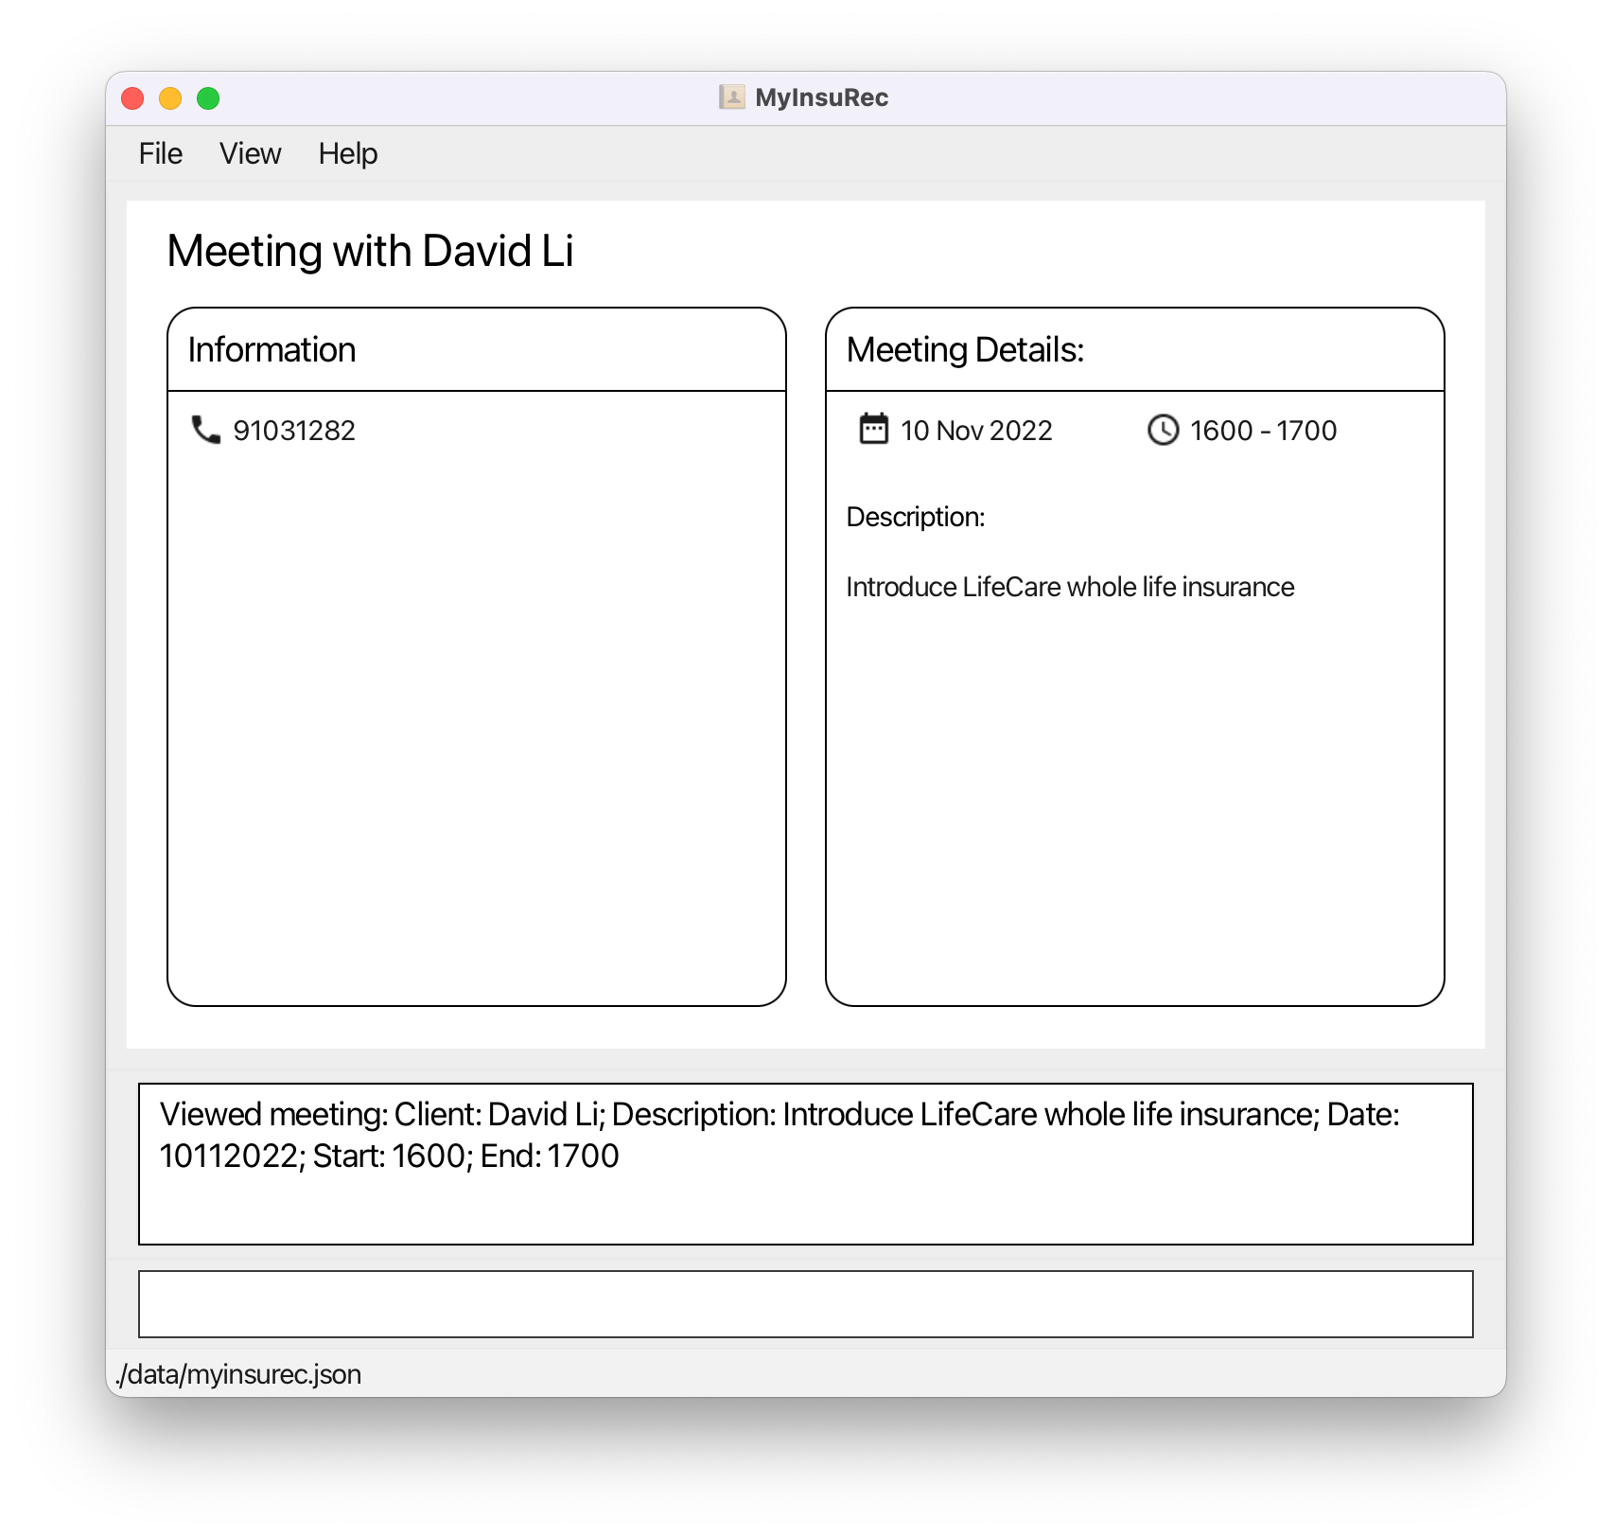

Client’s Information

Meeting with Client

Meeting’s Information

Product Name

Product List